Daiso Pricing & Promotion UI

User’s Guide
Version 1.0



Table of Contents
1. Overview 3
2. Features 3
2.1 Sign in to Pricing UI Tool 3
2.2 Configuration Setup 4
2.2.1 Setup Regions 4
2.2.2 Add stores to an existing or new region. 6
2.3 Item Maintenance 8
2.3.1 Price Changes 8
2.3.2 Export all prices data per regions 13
2.4 Promotion Setting 14
2.4.1 What kind of Promotion Deal can we set? 14
2.4.2 Create a new Promotion Deal – Other Than “BOGO” related Promotions 15
2.4.3 Create a new Promotion Deal – “BOGO” related promotions 17
2.4.3 Update the Promotion Deal 19
2.5 Logout 20
3. Trouble Shoot 20
3.1 Inquiry Management 20
4. Reference Document 21
4.1 QA Sheet 21

Overview
The Pricing Tool enables users to update and manage product prices across multiple stores and regions.
The entire business process flow from Recollab/MD to Xenia POS of Pricing tool is described in the document below.
https://daisojapan365.sharepoint.com/:p:/r/sites/POS/_layouts/15/Doc.aspx?sourcedoc=%7B9AD514FF-4714-47A1-8363-816DB7F985BC%7D&file=XPOS_Pricing_Flow.pptx&action=edit&mobileredirect=true
This function will be extended to provide a separate promotion setting function, scheduled for the end of November 2024.

Features

2.1 Sign in to Pricing UI Tool
- Users open the Pricing UI tool and log in using their User ID and password.
Note: The Pricing UI can be accessed from any Windows device on the store network at the following URL: http://xposcsprod.westus.cloudapp.azure.com:232/
Note: You can use the following User ID. The functionality will be enhanced to issue individual User ID in the future. The timing has not yet been determined.
0001: paul.suroteguh
0002: amy.chow
0003: miller.holly
0004: prasanth.kammula
0005: yuki.matsuo
0006: Alyson Adler
0007: Ellen Kawata
0008: Kim Escalante
0009: Kat Morano
0010: Gus Aguilar
0011: Joseph Rubio
0012: Grey Miranda

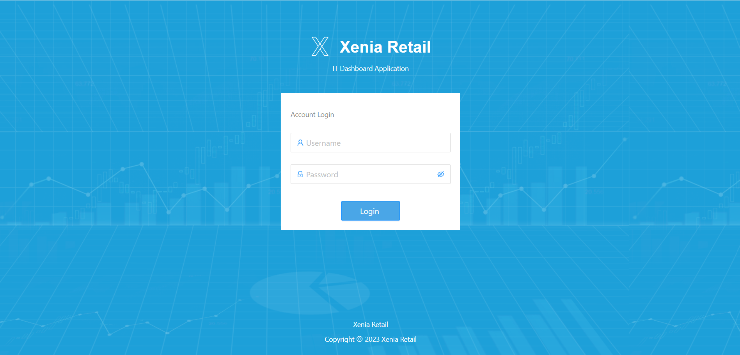

2. Sign in: After users log in using their credentials, they are directed to the Config Setup screen, where they can configure regions.
Config Setup Menu: From here, users can choose the Setup Region option to manage existing regions or add new ones.
The sidebar on the left also provides access to other functionalities like Item Maintenance.
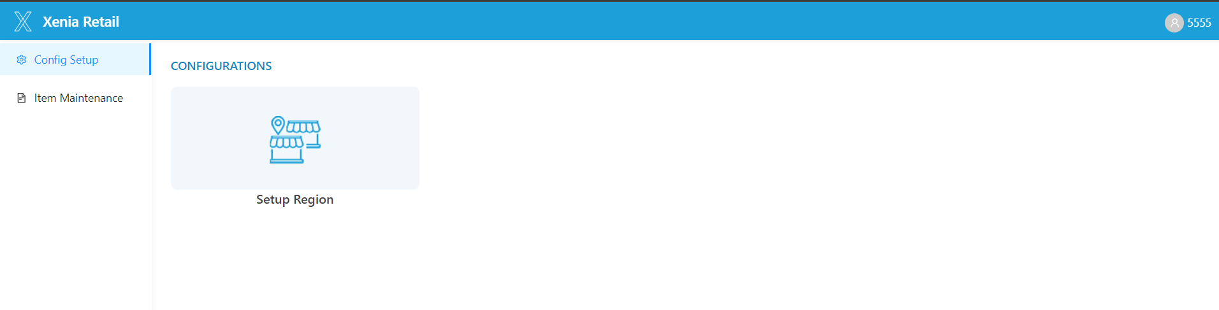

2.2 Configuration Setup

2.2.1 Setup Regions
- After signing in, the Config Setup screen appears, as shown in the image.
- To manage regions, select Setup Region from the Configurations section.
- There are 2 types of Regions. Pre-Defined Region and User-Defined Region.
  - Pre-Defined Region: Regions that the system is set up from the beginning. User can not edit this region setting.
    - Default:
Standard price linked from MD system. This value will be updated in System Integration with MD on a daily basis. Values updated in Recollab by 6:00 PM PST daily will be linked at 12:05 AM PST.
Here is the Link of system flow for your reference: Link
    - Standard:
Standard price applicable to all stores that do not belong to a User-Defined Region
  - User-Defined Region: Regions that can be added by the user for different purposes
    - NY/NJ:
The price applicable to all stores that belong to NY/NJ Region.
- To view or edit an existing region, choose the region from the drop-down menu.
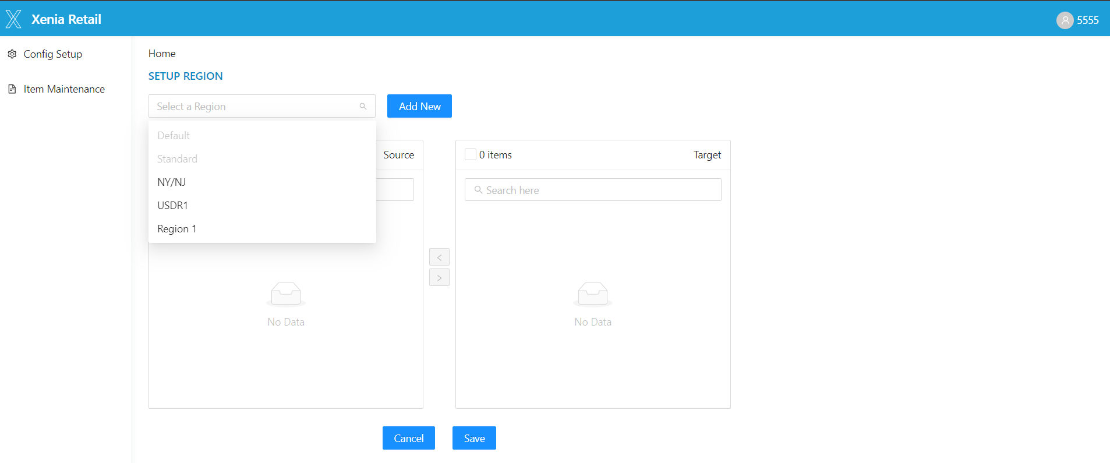
- To create a new region, click the Add New button.
Enter the region name and click OK.

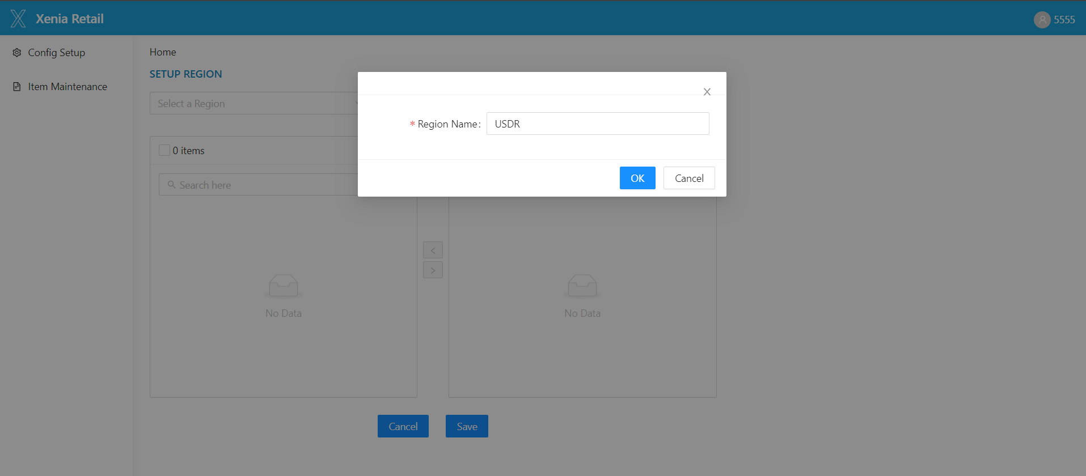

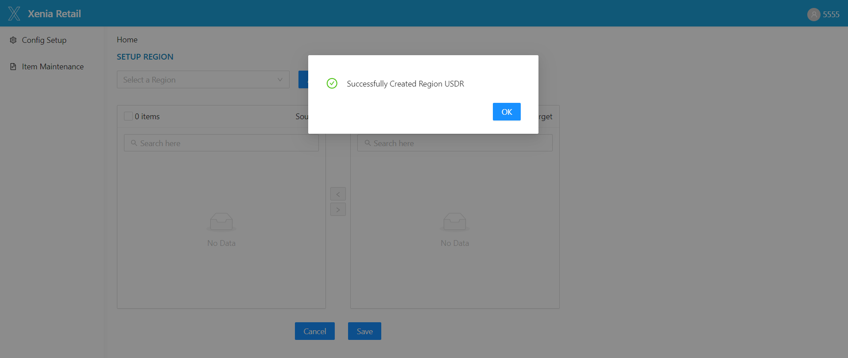

- If you want to delete the Regions or change the name of Regions, please reach out to Xenia Team.

2.2.2 Add stores to an existing or new region.
- Basically, when we get new store, the store automatically added to the Standard Region
- To add stores to User-Defined Region:
Select stores from the Source list on the left and select the > button, stores will be added to the Target List and Select Save.
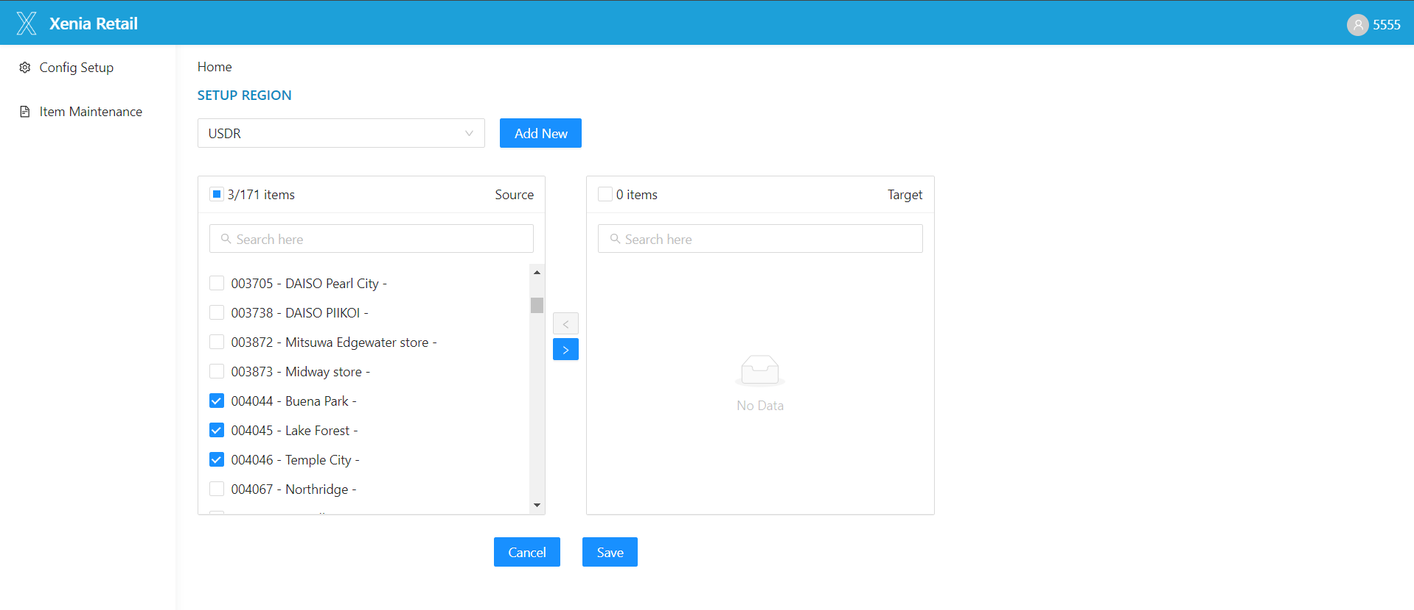

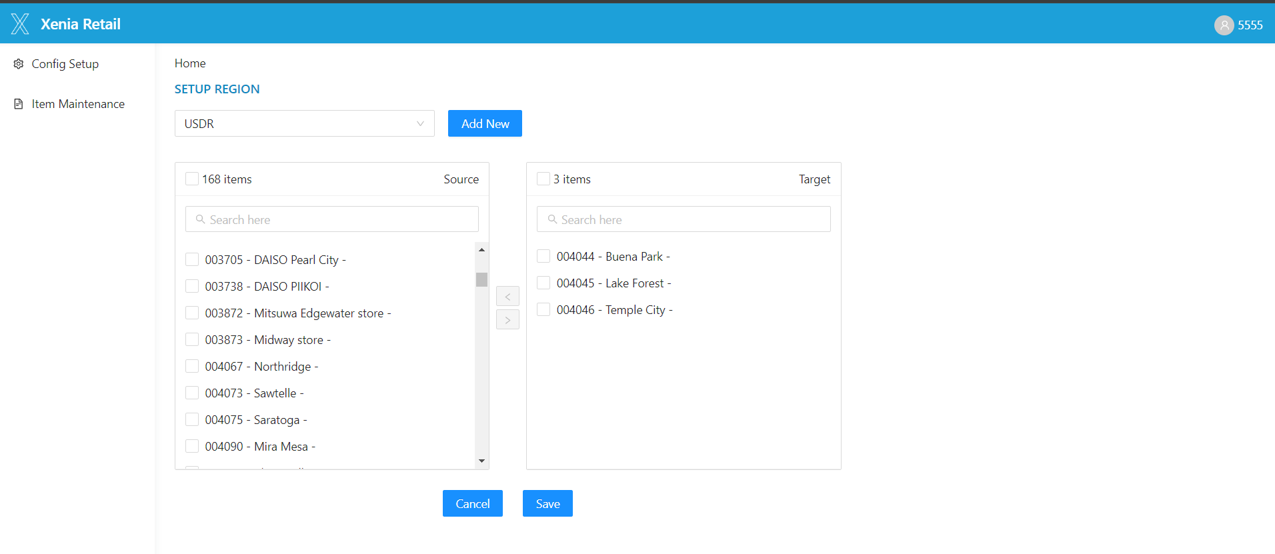

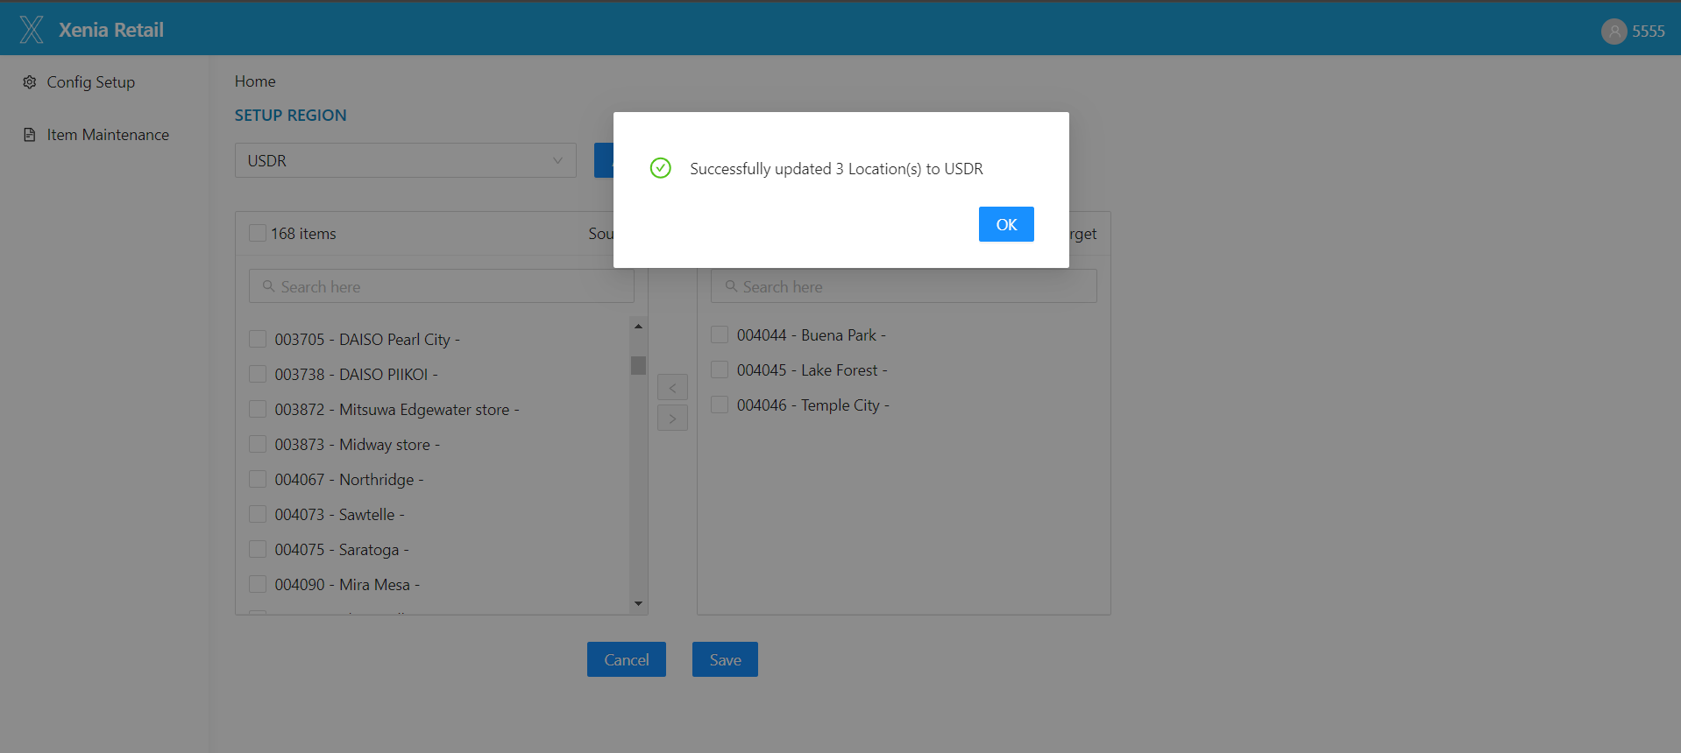
*Stores added to a User-Defined Region can be removed from the Standard Region automatically.
- To remove stores from User-Defined-Region:
Select Setup Region. à Select user defined region from List à Select the stores from the Target stores list and click the < button and select save option.
àStores will be removed from the region.
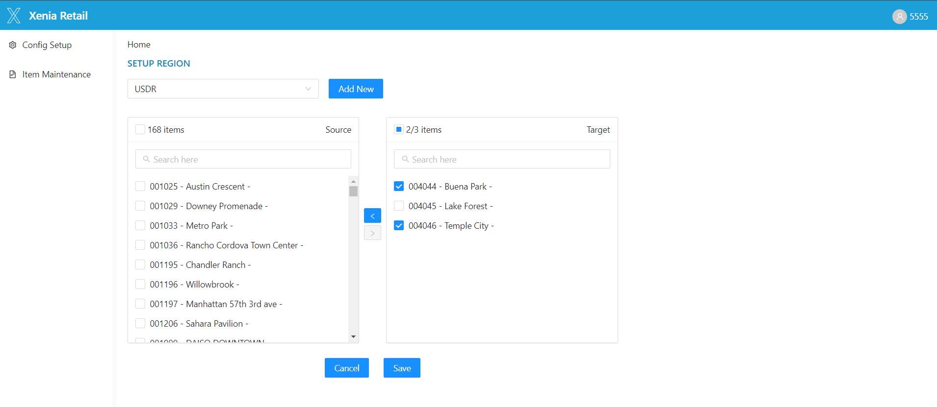

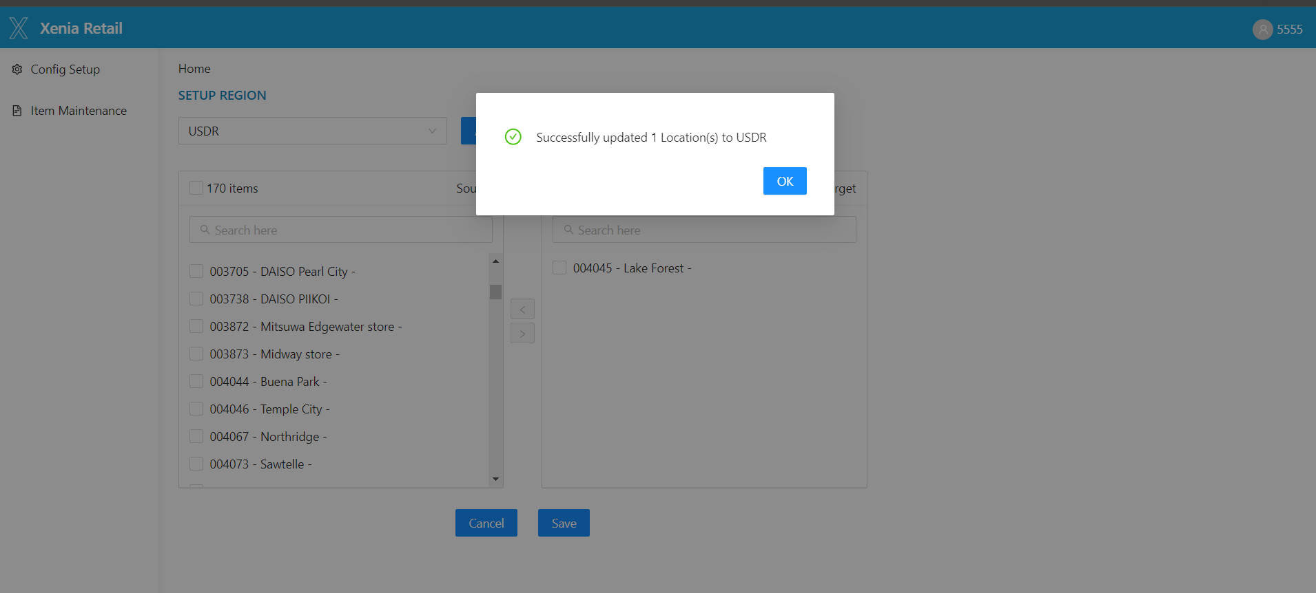
*Stores removed from a User-Defined Region can be added to the Standard Region automatically.

2.3 Item Maintenance

2.3.1 Price Changes
When updating prices, users have two options:
Process Immediately
Effective Date (PST Time Zone)
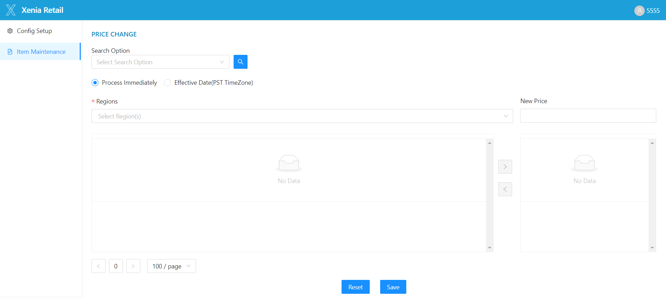

2.3.1.1 Process Immediately method.
- To change the price of an item, select a search option from the drop-down menu and select any search option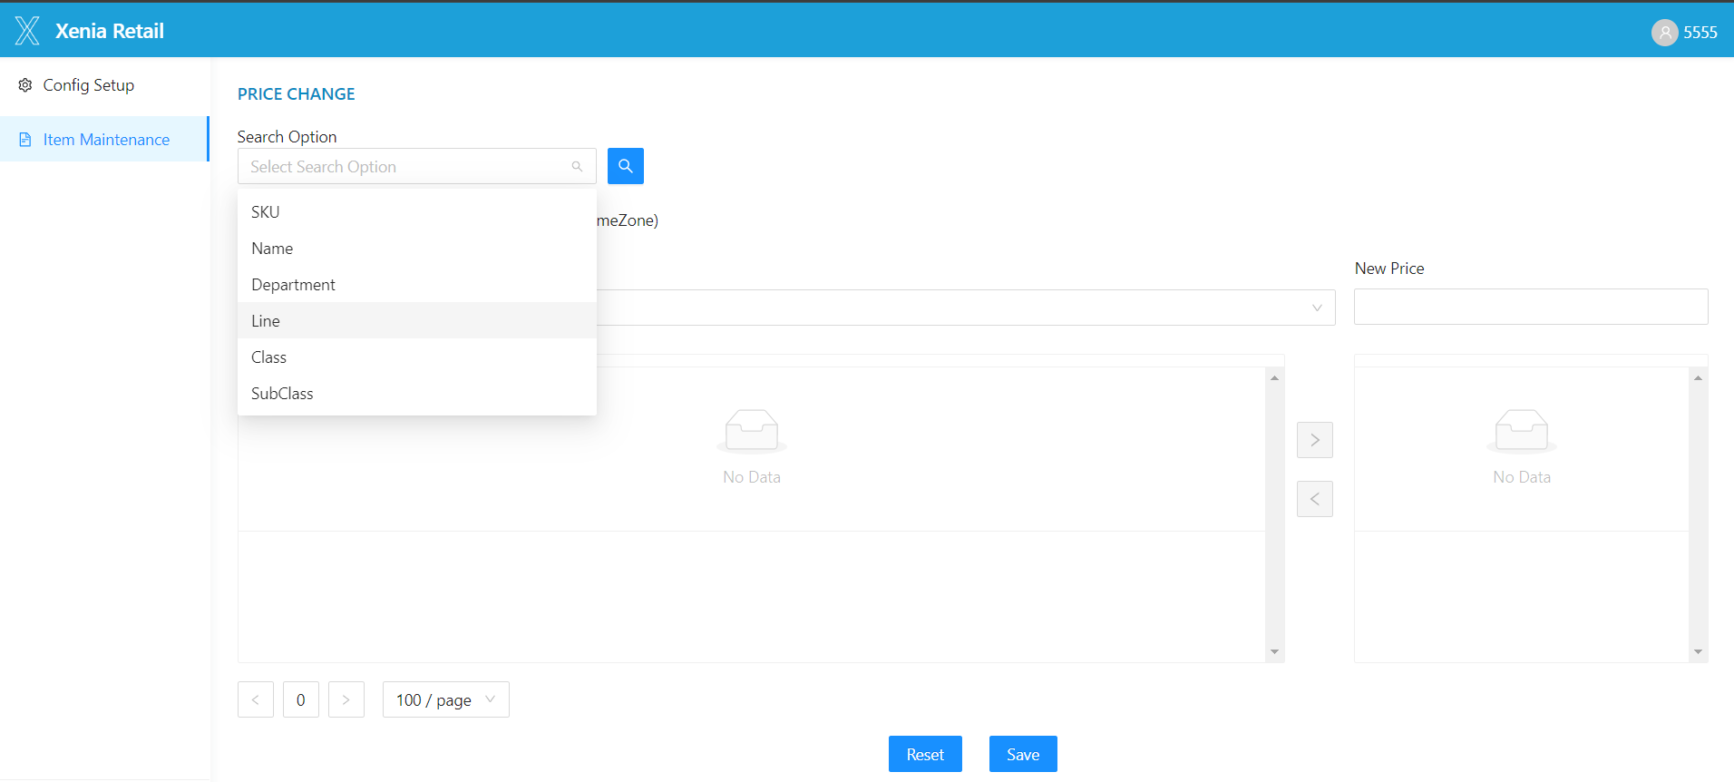
- Select SKU – Tool displays the Search with SKU entry field.
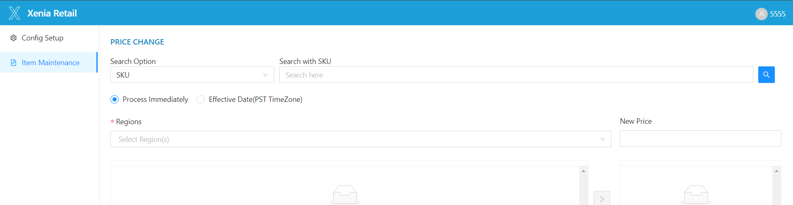
- User can enter SKU(s) and select Search icon.
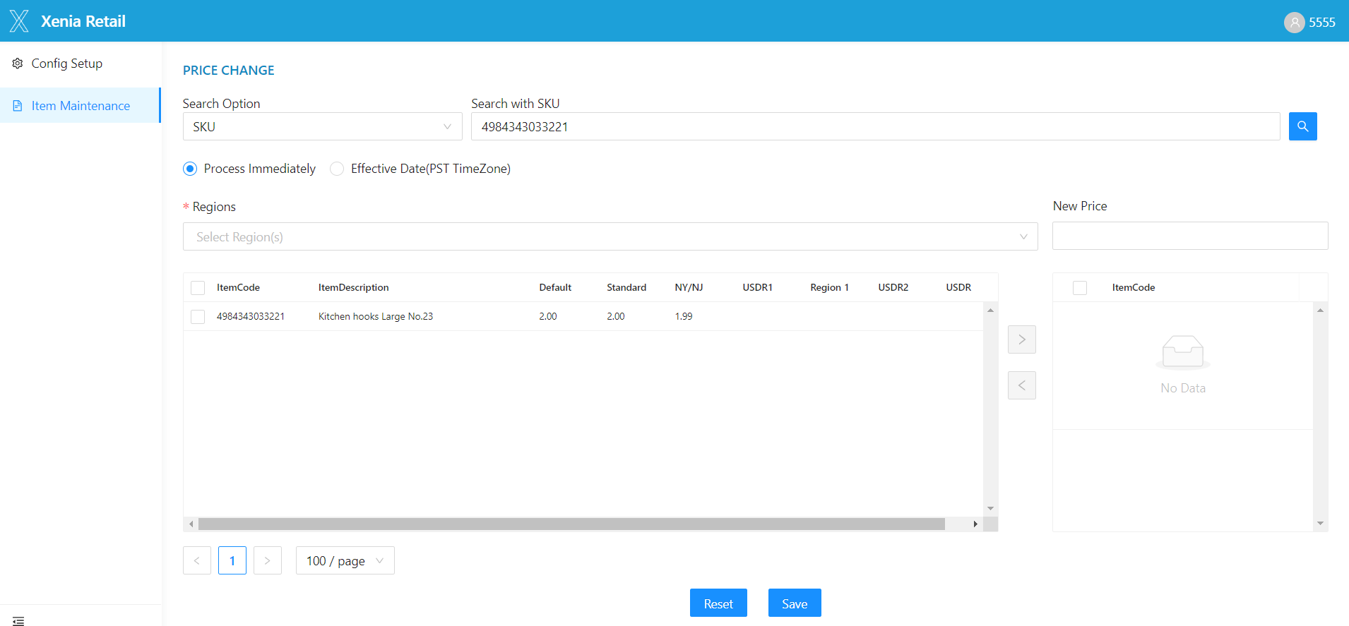
- System display the search SKU details with different regions prices.
- Choose the item(s) you want to updateà Select > optionà SKUs moved to ItemCode section.
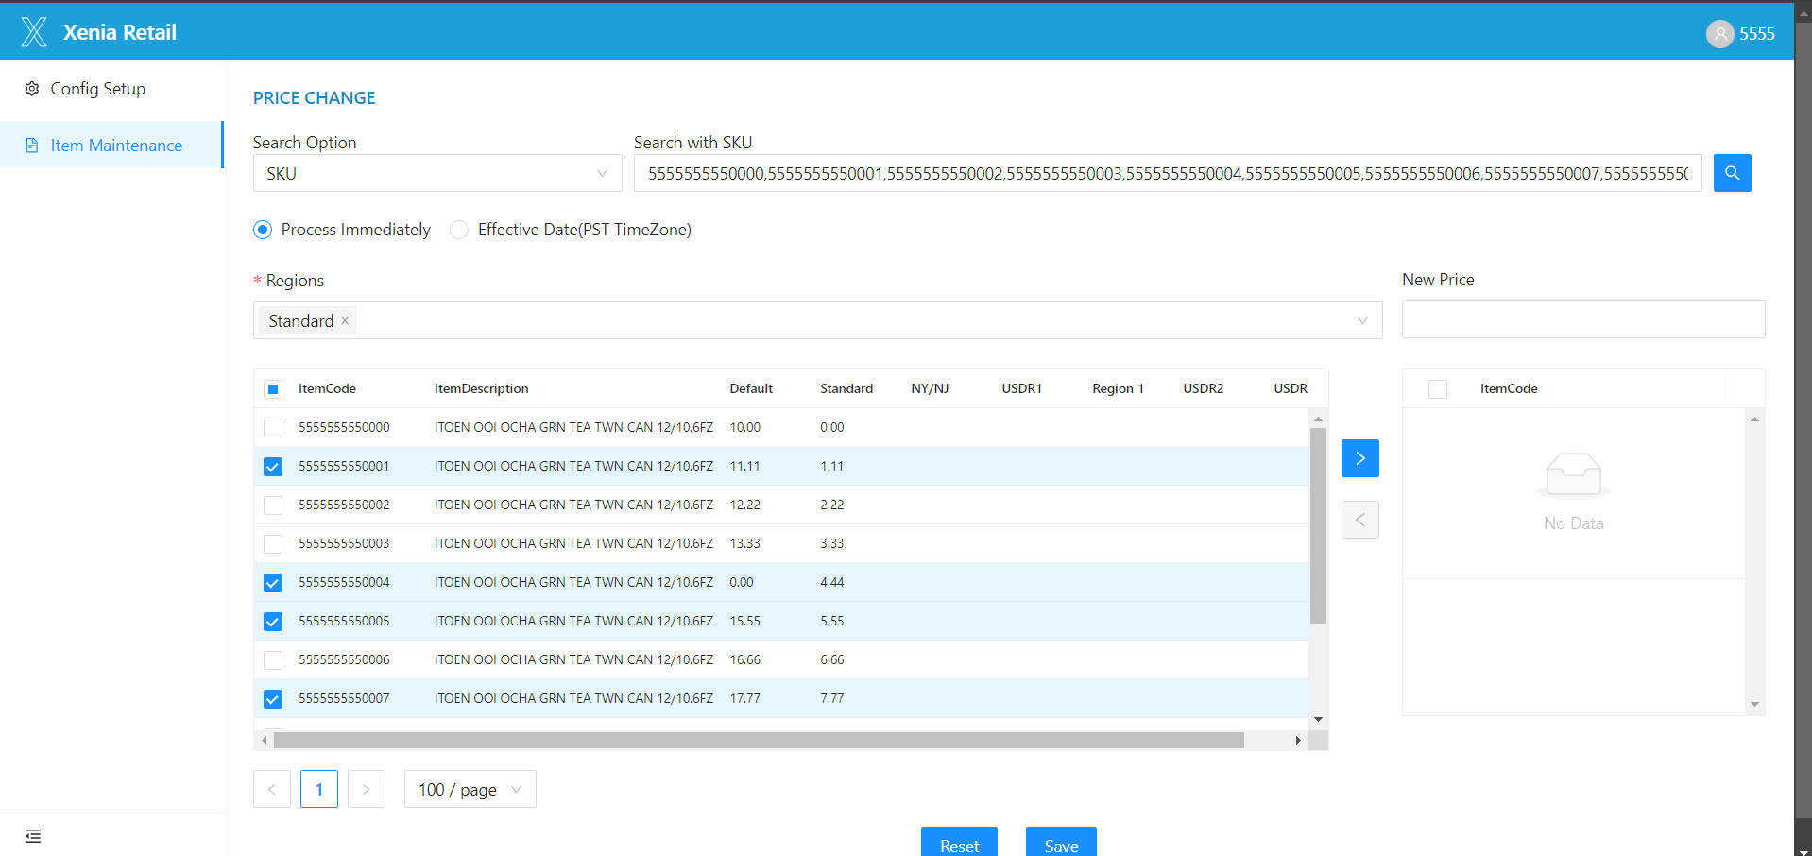
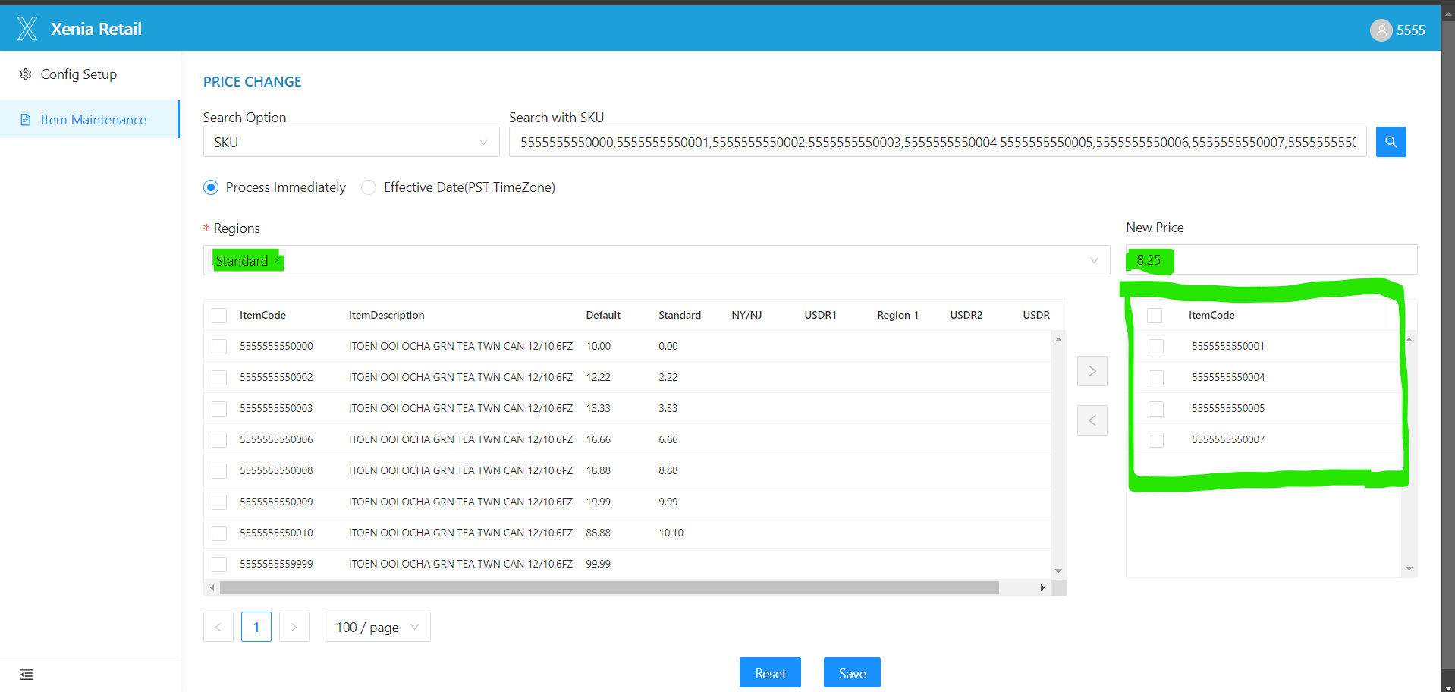
- Select the region where you want the price change to apply.
- Enter the new price in the New Price field. Please enter the price with two decimals(say 1.75 or 10.55).
- Click Save to update the price for the selected SKUs under the selected Region.
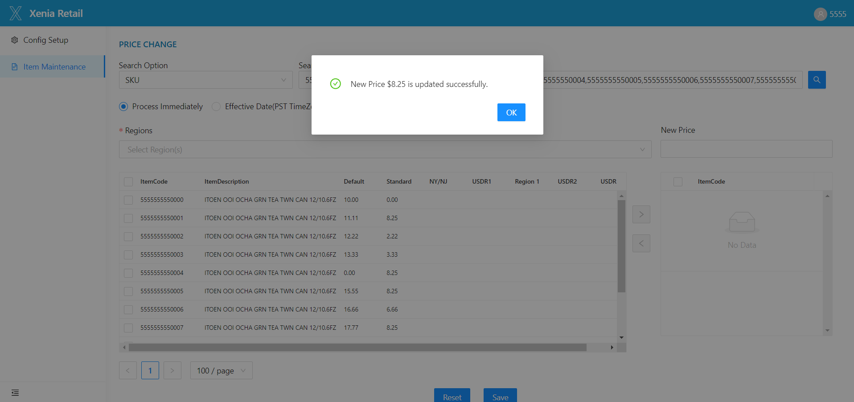
Note: If Process Immediately is selected, the system will push the price change to Xenia POS within ~15minutes.
- User can select different search options (Name, Department, line, class and subclass) and update the SKU(s) prices.
- Select reset option to reset the data.
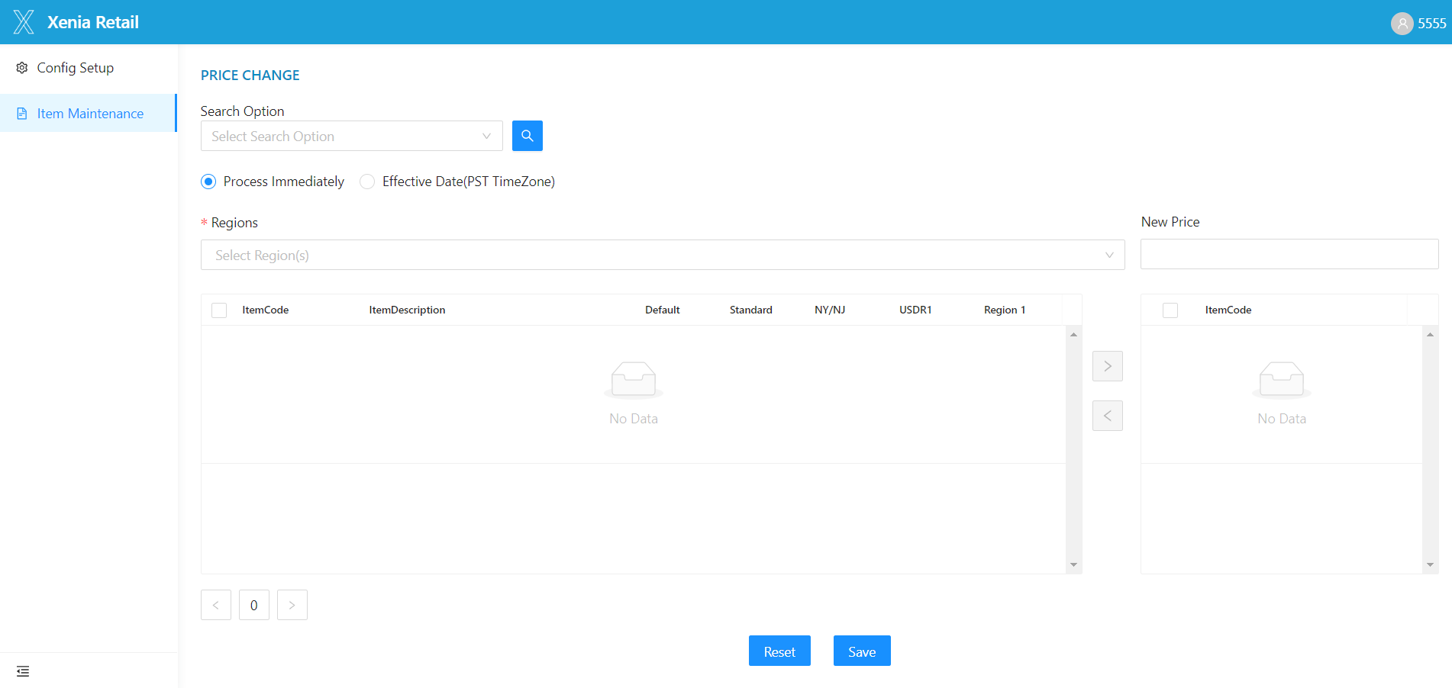

2.3.1.2 Select Effective Date (PST Time Zone)
- Navigate to the desired item(s) by selecting a search option from the drop-down menu and entering the search criteria.
- The system will display a filtered list of items based on the entered criteria.
- Select Effective Date (PST Time Zone). A calendar and time picker will appear, allowing you to schedule the price change.
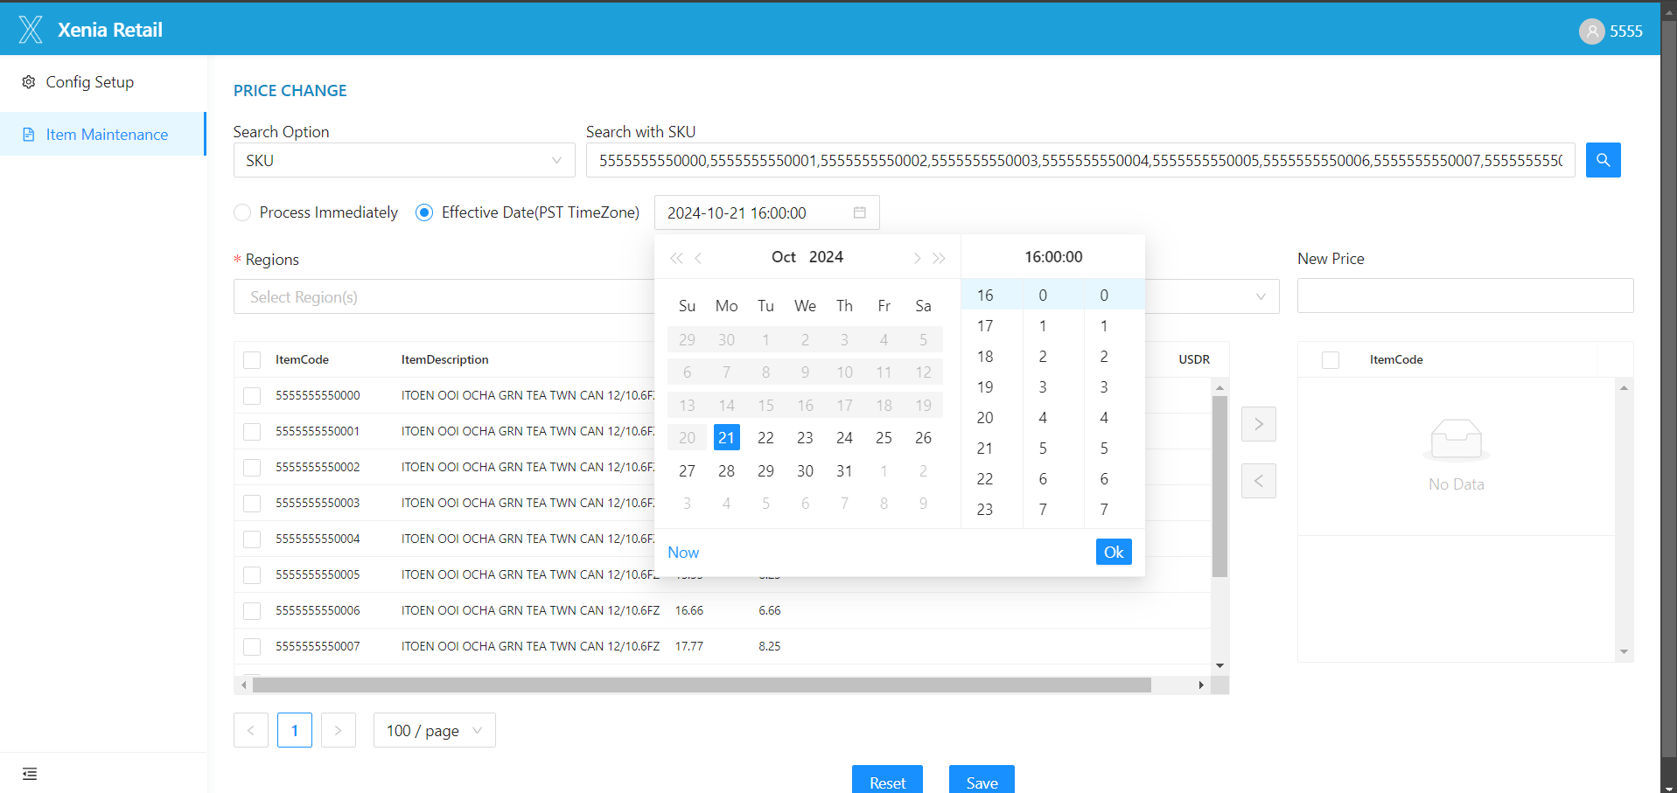
- Choose the item(s) you wish to update.
- Select the region where you want the price change to apply.
- Enter the new price in the New Price field. Please enter the price with two decimals(say 1.75 or 10.55).
- Click Save to schedule the price update.
Note: If you select Effective Date (PST Time Zone), the price change will be applied to Xenia POS after the scheduled date and time.
- To reset the page to its original state, click Reset.

2.3.2 Export all prices data per regions
- In the future, Xenia will provide the ability to export data.
- Until then, the following data extract tools is provided as a temporary solution.
- Click Here to Download

2.4 Promotion Setting

2.4.1 What kind of Promotion Deal can we set?
- Here is the promotion type we can set.
Deal Type | Sample - Deal Name | Sample - Deal Description | Manual Page
X% Off | 15% off for Black Friday | Buy 1 for 15% off | Go to Page 15
$X Off | $1 off for Black Friday | Buy 1 for $1 off
X for $Y | 2 for $4 | Buy 2 for $4 total
 | 3 for $1 off | Buy 3 for $1 off from total
 | 4 for $3 each | Buy 4 for $3 per item
BOGO | BOGO for Free | Buy 1 Get 1 for Free | Go to Page 17
 | BOGO for 50% off | Buy 1 Get 1 for 50% off

2.4.2 Create a new Promotion Deal – Other Than “BOGO” related Promotions

2.4.2.1 Set up a basic Deal information – Name and Date, Location
- Enter a Basic Information on the Create Deal Screen
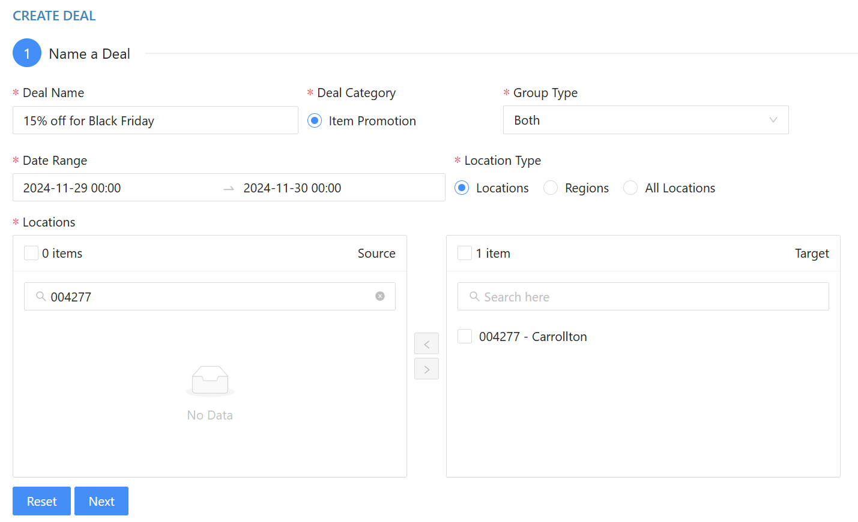
  - Deal Name: Enter the Deal Name – It will show up on the POS screen and Receipt
  - Deal Category: Item Promotion
  - Group Type: Select “Both” option
  - Date Range: Enter the Start and End Date time of the promotion
  - Location Type: Select the location type for this promotion
  - Locations: Select the locations for this promotion
- Note: POS Register Screen Image
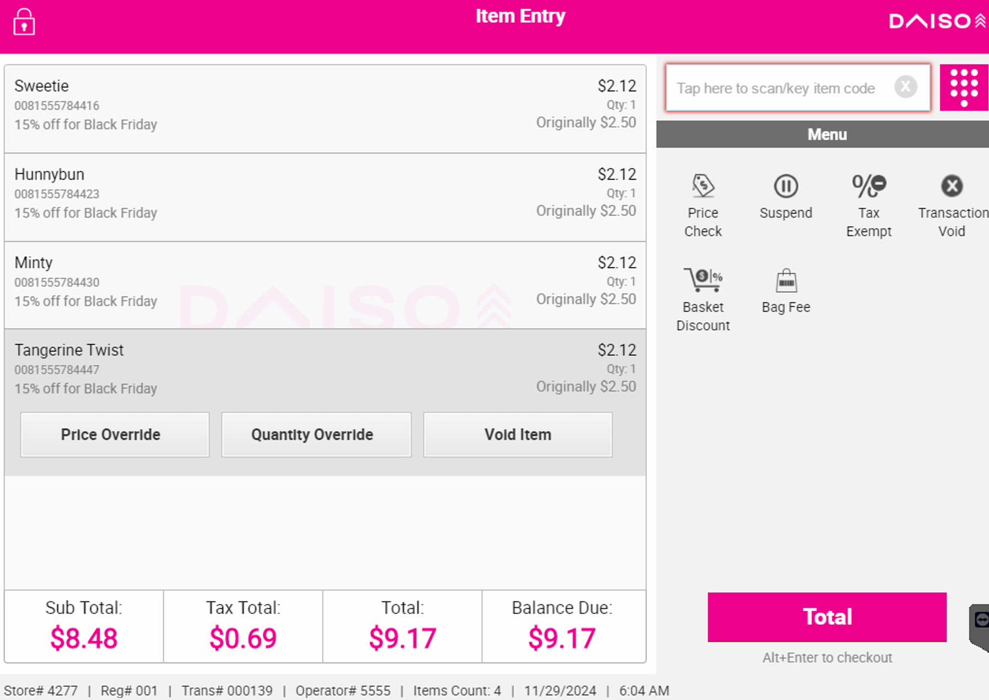
- Click the Next Button

2.4.2.2 Set up detailed Deal information - Triger and Benefit
- Enter the Triger and Benefit to the following screen. Below are sample entry instructions for entering various promotional deals. Please use this as a reference to set up the various values and SKUs as you need. 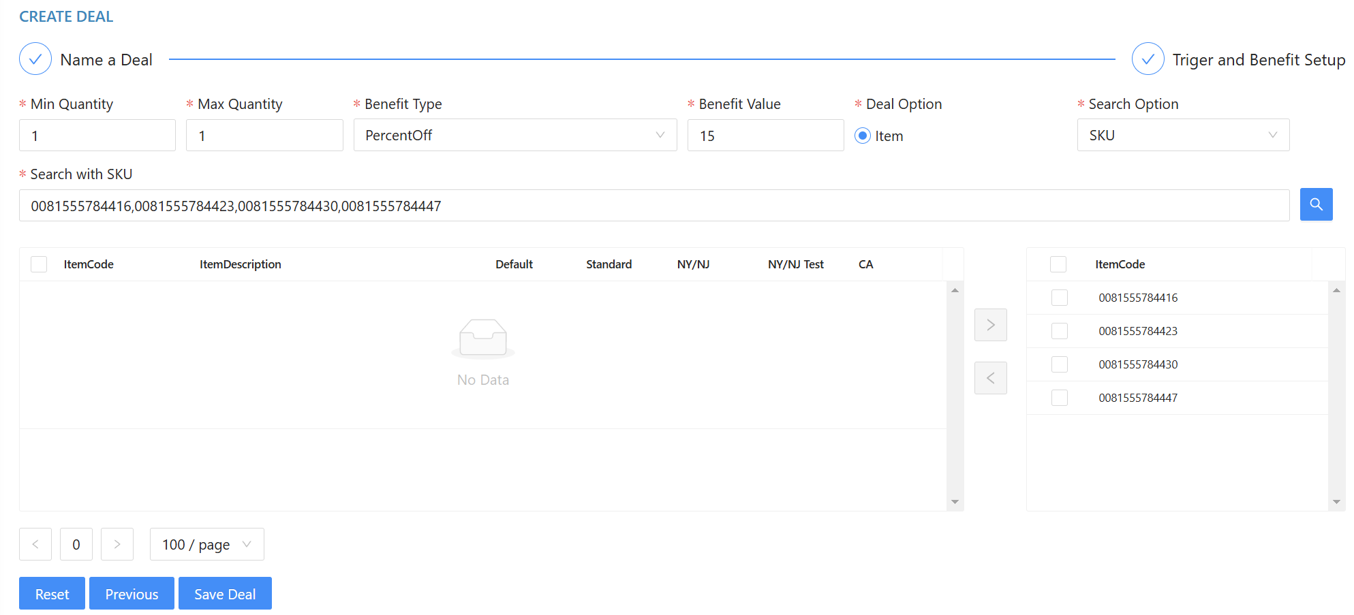
Deal Name | Min Quantity | Max Quantity | Benefit Type | Benefit Value | Deal Option | Search Option
15% off for Black Friday | 1 | 1 | PercentOff | 15 | Item | Select / Enter the SKUs you need to add
$1 off for Black Friday | 1 | 1 | GroupDollarOff | 1 | Item
2 for $4 | 2 | 2 | GroupFixedPrice | 4 | Item
2 for $1 off | 3 | 3 | GroupDollarOff | 1 | Item
2 for $3 each | 4 | 4 | ItemFixedPrice | 3 | Item

- Click Save Deal button, then the following pop up will show up as a reference.
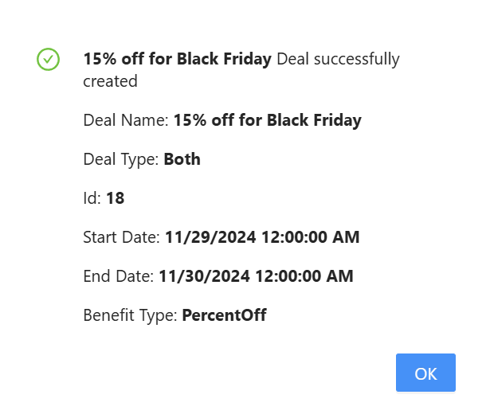

2.4.3 Create a new Promotion Deal – “BOGO” related Promotions

2.4.3.1 Set up a basic Deal information – Name and Date, Location
- Enter a Basic Information on the Create Deal Screen
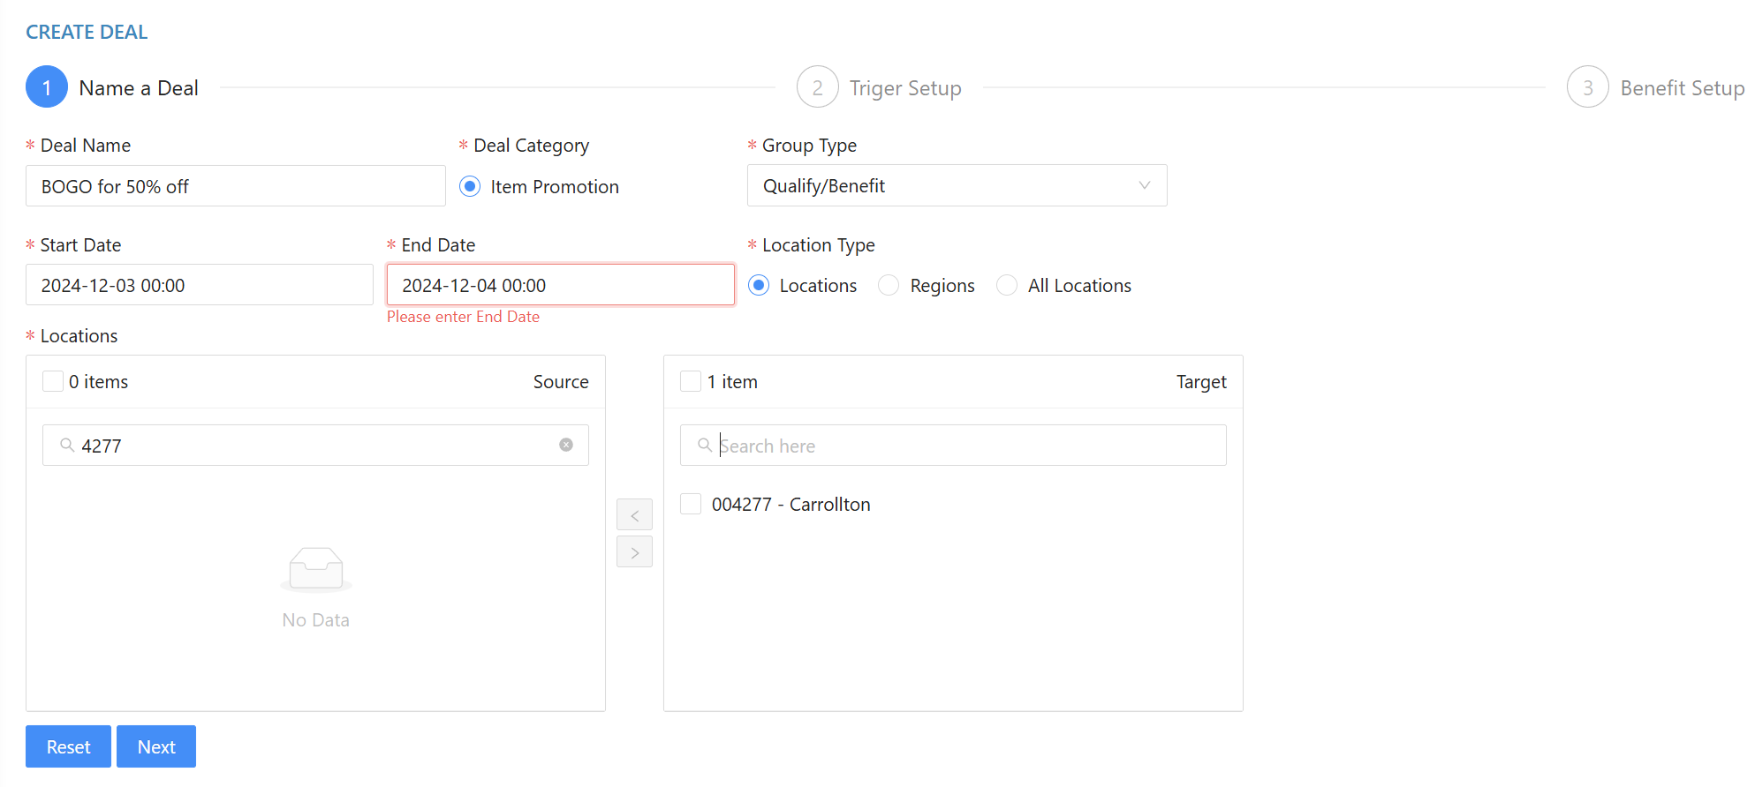
  - Deal Name: Enter the Deal Name – It will show up on the POS screen and Receipt
  - Deal Category: Item Promotion
  - Group Type: Select “Qualify/Benefit” option
  - Date Range: Enter the Start and End Date time of the promotion
  - Location Type: Select the location type for this promotion
  - Locations: Select the locations for this promotion
- Click the Next Button

2.4.3.2 Set up detailed Deal information - Triger Setup
- Enter the Triger to the following screen.
This screen is only show up when you select “Qualify/Benefit” option for “BOGO” deals.
Below are sample entry instructions for entering various promotional deals. Please use this as a reference to set up the various values and SKUs as you need.
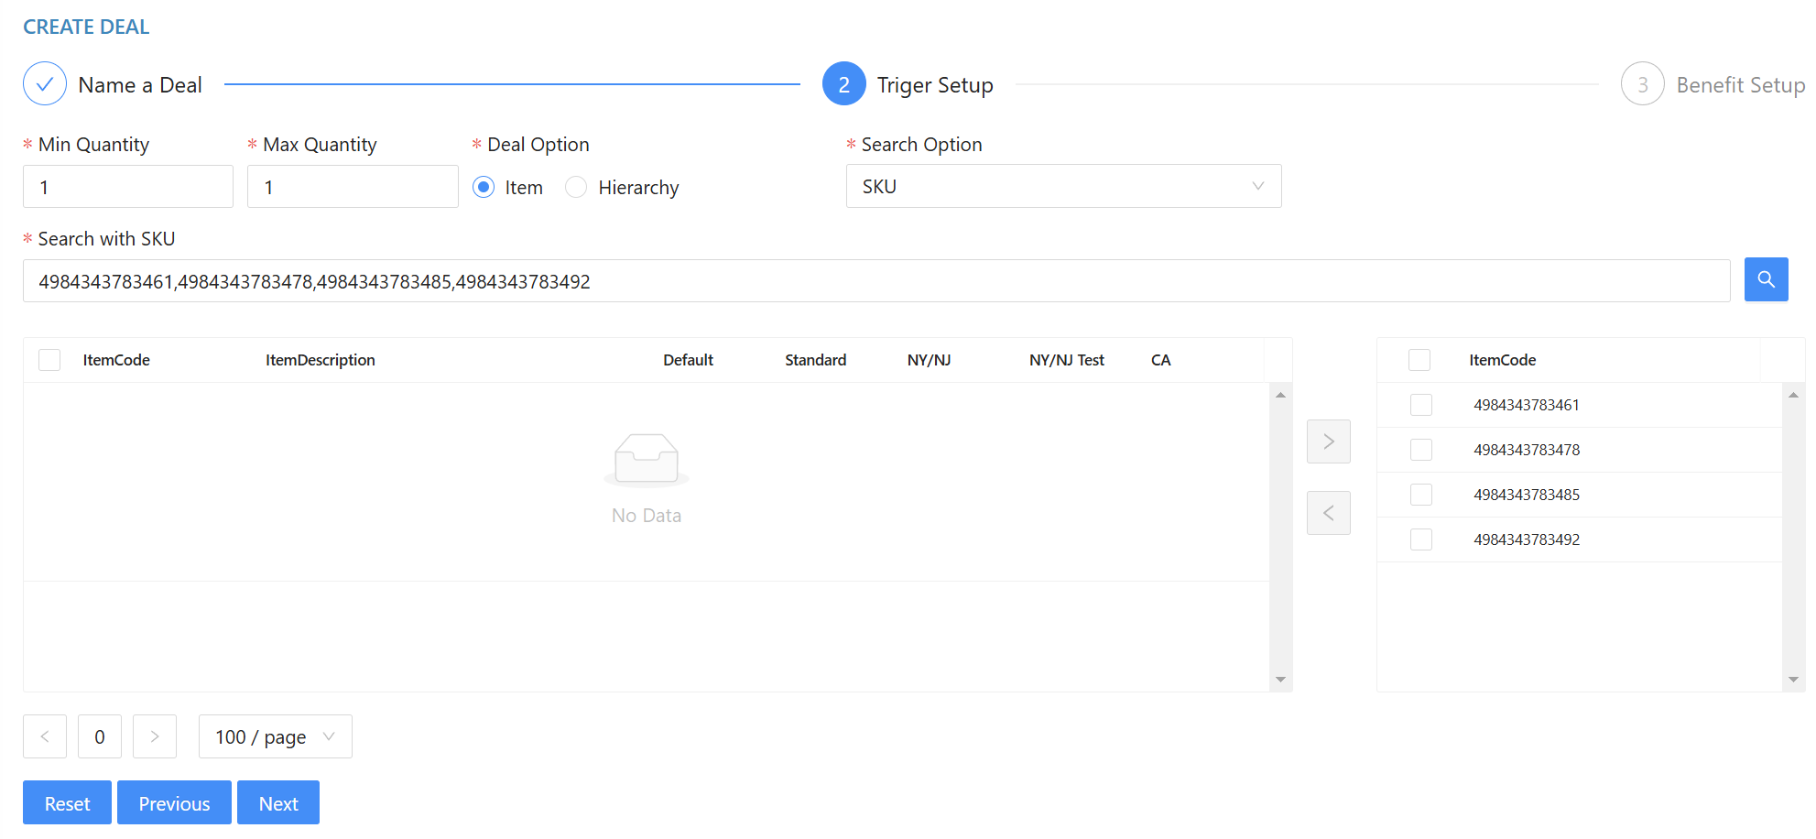
Deal Name | Min Quantity | Max Quantity | Deal Option | Search Option
BOGO for Free | 1 | 1 | Item | Select / Enter the SKUs you need to add
BOGO for 50% off | 1 | 1 | Item

- Click the Next Button

2.4.3.3 Set up detailed Deal information - Benefit
- Enter the Benefit to the following screen. Below are sample entry instructions for entering various promotional deals. Please use this as a reference to set up the various values and SKUs as you need.
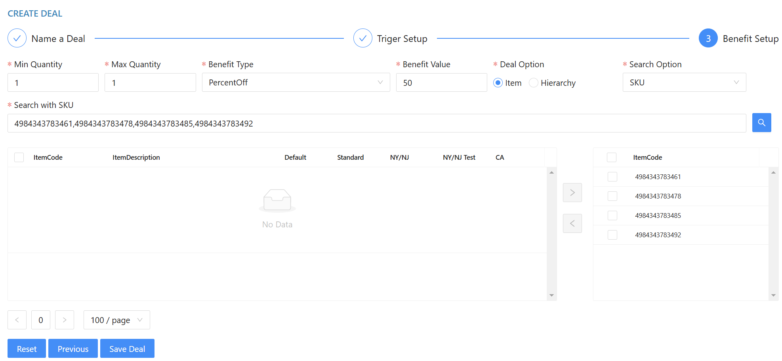
Deal Name | Min Quantity | Max Quantity | Benefit Type | Benefit Value | Deal Option | Search Option
BOGO for Free | 1 | 1 | PercentOff | 100 | Item | Select / Enter the SKUs you need to add
BOGO for 50% off | 1 | 1 | PercentOff | 50 | Item

- Click Save Deal button, then the following pop up will show up as a reference.
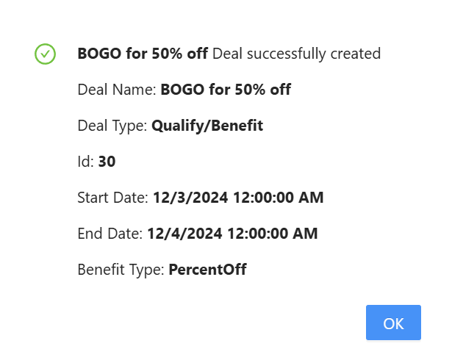

2.4.3 Update the Promotion Deal
- To be released this function in the future. Meantime, please reach out to XXX when you need a support.

2.5 Logout
- To log out, click the Log Out icon at the top right of the screen.
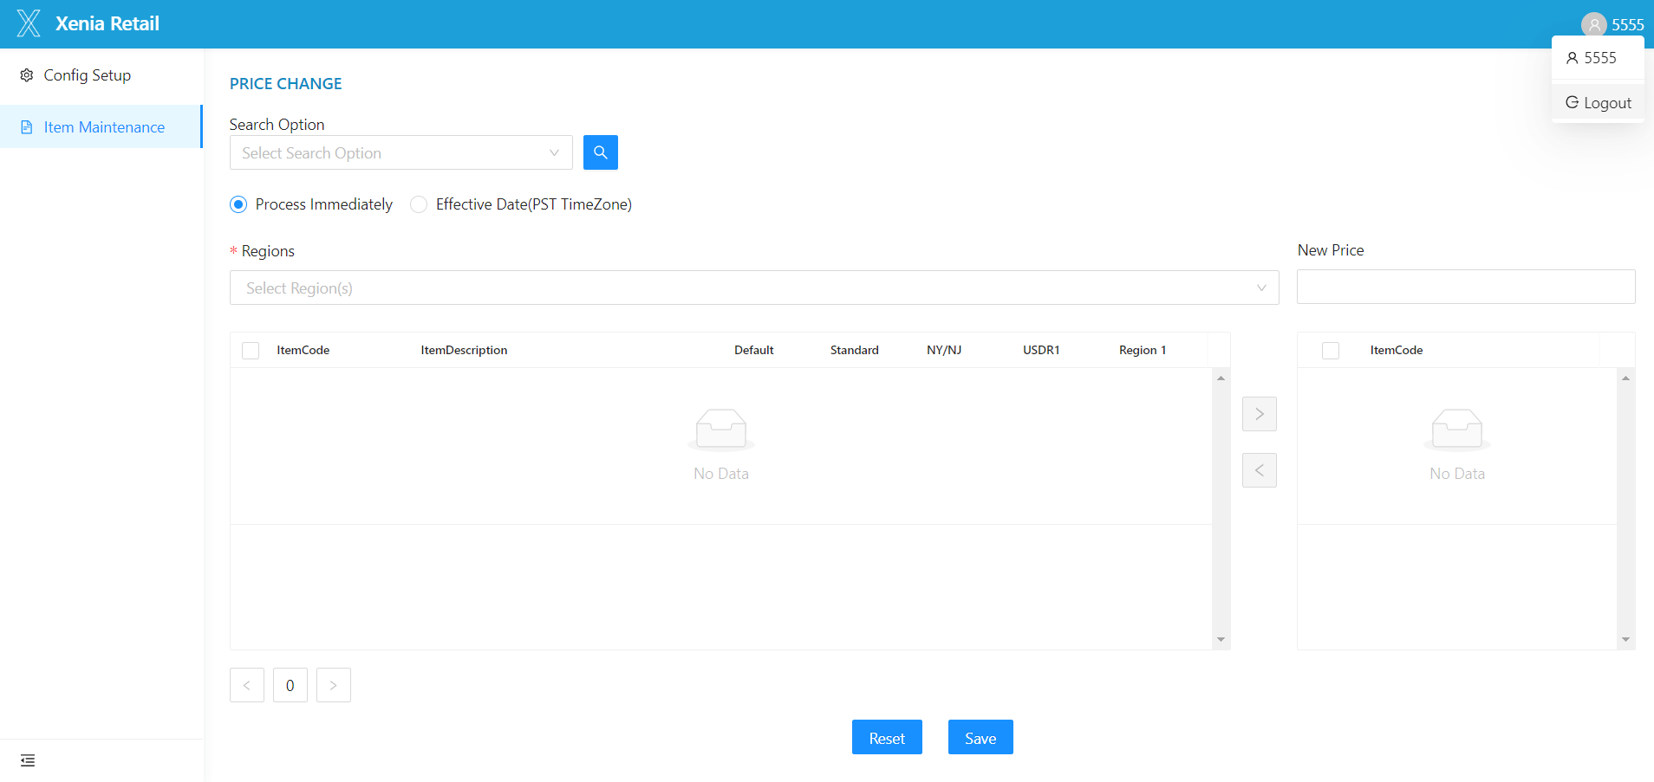
- The system will log you out and return you to the Pricing UI sign-in screen.

Trouble Shoot

3.1 Inquiry Management
- Flowchart for handling inquiries from stores about incorrect prices.
  - Step 1: Is the price per region set in the Price UI Tool, correct?
    - Yes -> Go to Step 2
    - No -> Request Merchandising team to update the price in the tool.
  - Step 2: Is the region for the store set in the Price UI Tool, correct?
    - Yes -> Go to Step 3
    - No -> Update the region setting and request Xenia to reflect region price
  - Step 3: Are the prices of the SKUs in the target store in Central Server correct?
Power BI : Click Link
    - Yes -> Remote Login to the Store Register and Check to see if the price is not reflected in all registers or only some of them, and request Xenia to update the regional price.
    - No -> Set the same price again using the Price UI Tool. If it is still not reflected, request Xenia to fix it.

Reference Document

4.1 QA Sheet
- If you have any questions or additional request for the function, please put your feedback to the QA sheet below.
QA Sheet : Click Link

